**Project Report on designing a Database for Car Rental Company**

(This report is continuation of project report submitted in Dec 2016)

**Submitted By :**

**Srikanth Mandula**

**FSU ID: 3080786**

**Frostburg State University**

Below are the Tables considered for Project development. These tables are developed as part of DBMS-1 project.

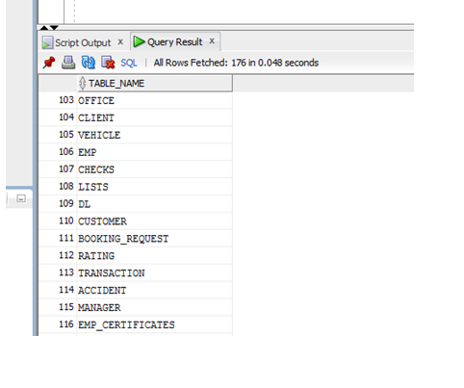

**12 a) Creating *Employee_Info* view**

**Query:**

create or replace view employee_info as select a.f_name||' '||a.m_name||' '||a.l_name full_name,a.home_ph_no,a.cell_ph_no,a.flat_no,a.street_name,a.city,a.state,a.zipcode,a.ssn,a.salary,a.dob,(sysdate-a.dob)/365 age,a.marital_status,a.spouse_name,b.name office_name,

a.last_degree,c.f_name||' '||c.m_name||' '||c.l_name mgr_name from emp a,office b,emp c where a.office_id=b.office_id and a.mgr_id=c.emp_id;

**Output:**

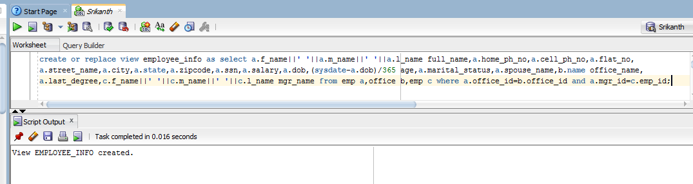

**12 b) Creating *Employee_Salary* view**

**Query:**

create or replace view employee_salary as select a.f_name,a.l_name ,a.flat_no,

a.street_name,a.city,a.state,a.zipcode,a.ssn,a.salary,a.tax_deduction,a.dob,a.marital_status,b.name office_name,

(select max_sal from (select office_id, max(salary) max_sal from emp group by office_id) where office_id=a.office_id) maximum_sal,

(select round(avg_sal) from (select office_id, avg(salary) avg_sal from emp group by office_id) where office_id=a.office_id) average_sal

from emp a,office b where a.office_id=b.office_id;

**Output:**

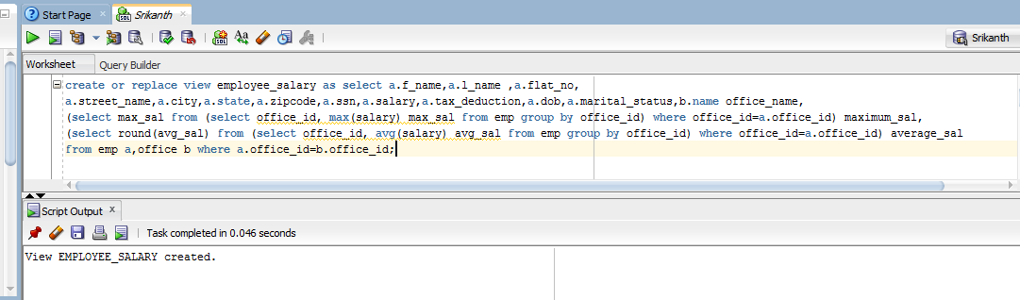

**12 c) Creating *Branch_Info* view**

**Query:**

create or replace view Branch_Info as select a.office_id,a.name,a.flat_no,a.street_name,a.zipcode,a.ph_number,a.fax_number,a.open_hours,

a.business_days,b.f_name||' '||b.l_name Manager_name, b.hiring_date assigned_date from office a,emp b where a.office_id=b.office_id;

**Output:**

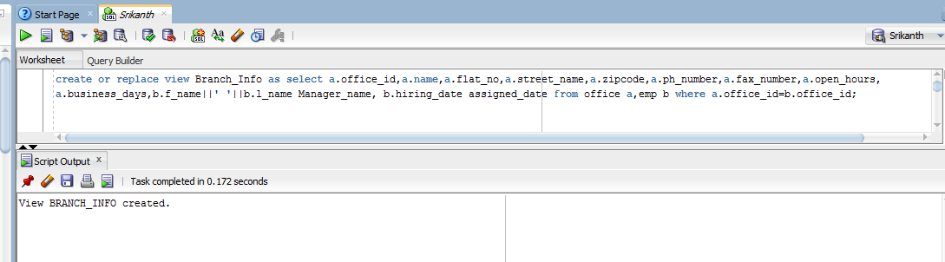

**12 d ) Creating *Valued_Customers* view**

**Query:**

create or replace view Valued_Customers as select a.f_name||' '||a.m_name||' '||a.l_name Name,round((sysdate-a.birth_date)/365) age,

a.cell_phone,a.flatno,a.street_name,a.city,a.state,a.zipcode,a.email_id,a.dl_num,b.dl_state,

(select count from (select cust_id,count(*) count from booking_request group by cust_id)where cust_id=a.cust_id) as no_of_rents

from customer a,DL b where a.dl_num=b.dl_num and (select count from (select cust_id,count(*) count from booking_request group by cust_id)

where cust_id=a.cust_id)>=4;

**Output:**

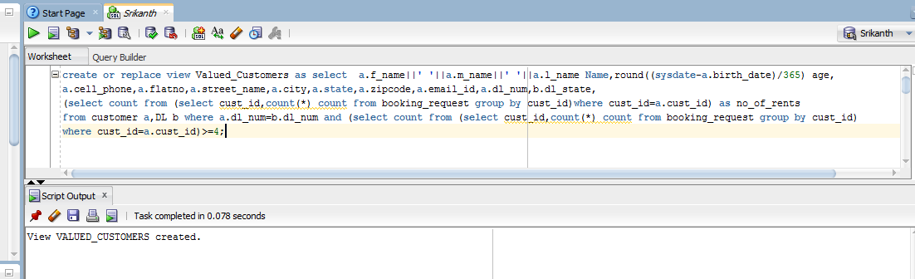

**12 e ) Creating *List_Of_Cars* view**

**Query:**

create or replace view List_Of_Cars as

select a.car_id,a.year,b.f_name||' '||b.l_name owner_name,a.class,

(select count from (select car_id,count(*) count from booking_request group by car_id) where car_id=a.car_id) no_of_times_car_rented,

a.make,a.color,

(select count2 from (select booking_id,count(*) count2 from accident group by booking_id) e,

booking_request f where e.booking_id=f.booking_id and f.car_id=a.car_id) no_of_Accidents,

(select sum(cost_of_damage) from accident h,booking_request i where h.booking_id=i.booking_id and i.car_id=a.car_id) total_cost_damage

from vehicle a,client b where a.clnt_id=b.clnt_id ;

**Output:**

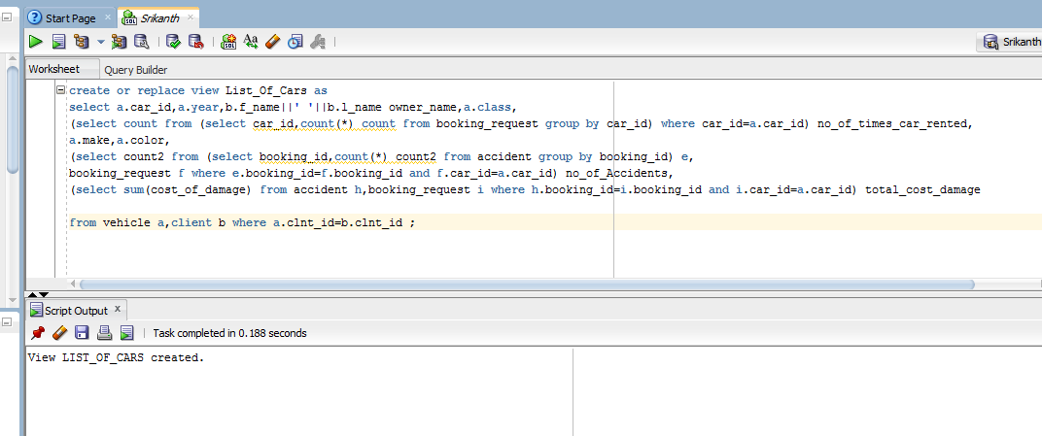

**12 f ) Creating *List_Of_Transactions* view**

**Query:**

create or replace view List_Of_Transaction as

select a.tran_id,(b.vehicle_req_upto -b.req_date) no_of_days,a.amount total_cost_of_transaction,

c.daily_price,((c.daily_price*7)-c.weekly_discount) price_week,((c.daily_price*30)-c.monthly_discount) price_month,

b.vehicle_location vehicle_return_loc,a.miles_run,(c.curr_mileage+a.miles_run) mileage_at_end,d.emp_id emp_worked_on_car

from transaction a,booking_request b,vehicle c,checks d,lists e

where a.booking_id=b.booking_id and b.car_id=c.car_id and c.car_id=e.car_id and e.clnt_id=d.clnt_id;

**Output:**

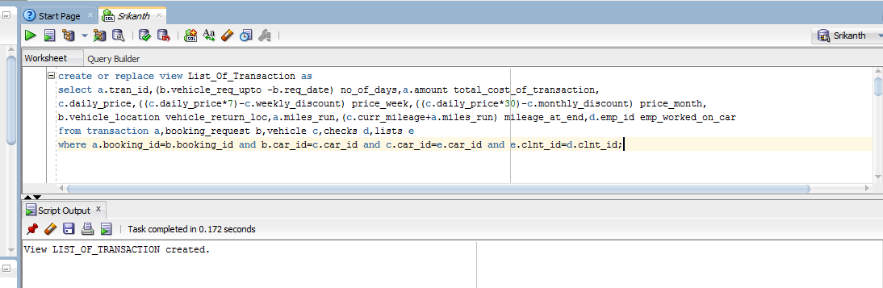

**12 g ) Creating *Statistics_by_Branch_Year* view**

**Query:** create or replace view Statistics_by_Branch_year as

select distinct a.office_id,b.f_name||' '||b.l_name client_name,to_char(c.registered_date,'yyyy') year,

(select count1 from (select clnt_id,to_char(registered_date,'yyyy') year_temp,count(*) count1 from lists

group by clnt_id,to_char(registered_date,'yyyy')) where clnt_id=b.clnt_id and year_temp=to_char(c.registered_date,'yyyy')) count_of_cars,

(select count2 from (select distinct d.clnt_id,to_char(e.req_date,'yyyy') req_date,count(*) count2 from vehicle d,booking_request e

where e.car_id=d.car_id group by d.clnt_id,to_char(e.req_date,'yyyy')) where clnt_id=b.clnt_id and req_date=to_char(c.registered_date,'yyyy')) no_of_trans,

(select total_amount from (select i.clnt_id,to_char(g.req_date,'yyyy') req_date,sum(h.amount) total_amount from booking_request g,

transaction h,vehicle i where h.booking_id=g.booking_id and g.car_id=i.car_id group by i.clnt_id,to_char(g.req_date,'yyyy'))

where clnt_id=b.clnt_id and req_date=to_char(c.registered_date,'yyyy')) total_amount

from office a,client b,lists c where a.office_id=b.office_id and b.clnt_id=c.clnt_id;

**Output :**

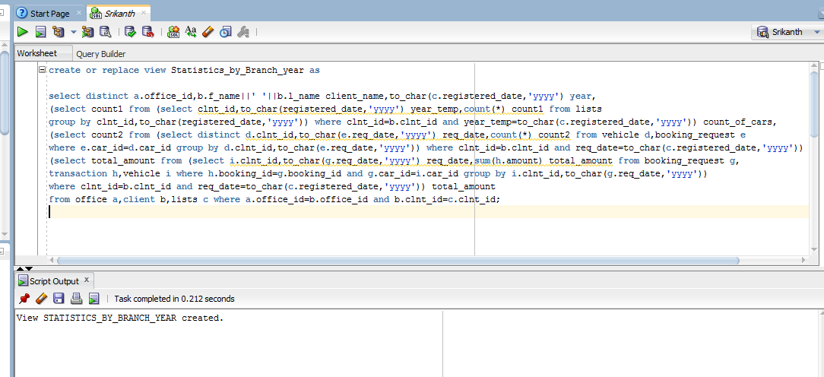

**Output :**

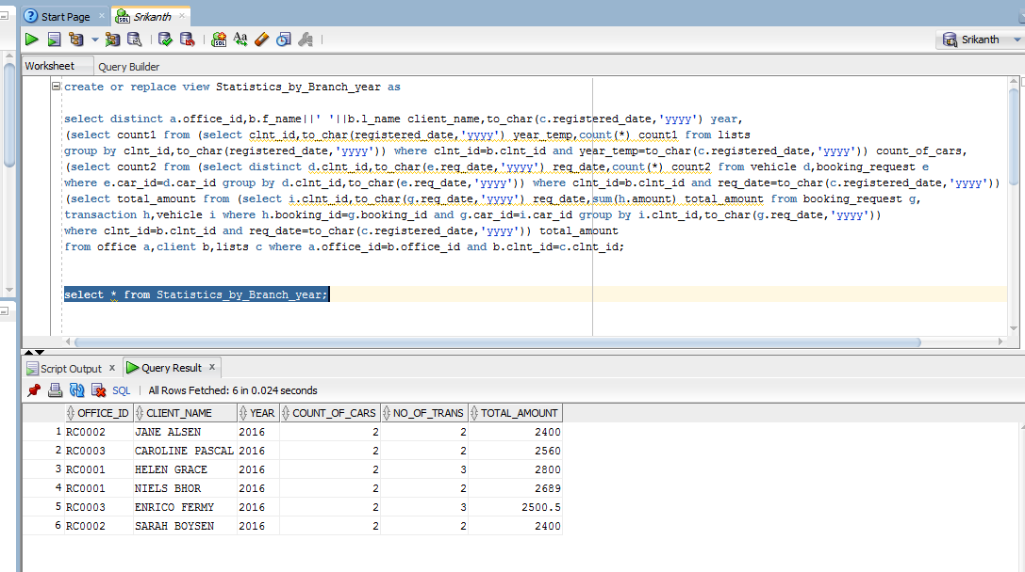

**12 h ) Creating *Last_employee_Branch* view**

**Query:**

create or replace view last_employee_branch as

select a.f_name||' '||a.l_name name,b.name office_name,a.hiring_date,a.salary,round((sysdate-a.DOB)/365) age

from emp a,office b where a.office_id=b.office_id and a.hiring_date=

(select min_date from (select office_id, min(hiring_date) min_date from emp group by office_id) where office_id=a.office_id);

**Output:**

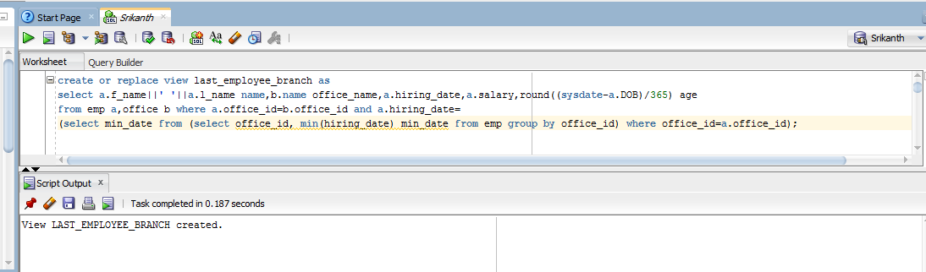

**12 i ) Creating *Managers* view**

**Query:**

create or replace view manager_view as

select a.f_name||' '||a.l_name manager_name,a.hiring_date manager_working_from,b.mgr_title,

(select count from (select manager_id,count(*) count from manager group by manager_id) where manager_id=a.emp_id) no_of_emp_reporting from

emp a,manager b where a.emp_id=b.manager_id;

**Output:**

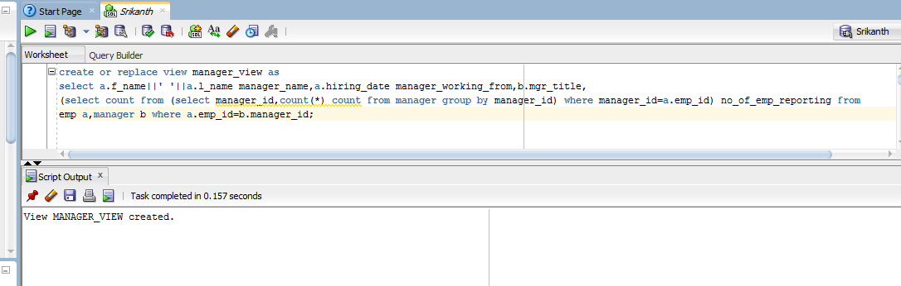

**12 j)**

Creating a view to list the number of bookings a customer has done at his registered office.

**Query:**

create or replace view cust_bookings_at_home_office as

select a.cust_id,a.f_name||' '||a.l_name cust_name,a.office_id cust_registered_office,

(select count1 from (select e.office_id,c.cust_id,count(*) count1 from booking_request c ,vehicle d,client e

where c.car_id=d.car_id and d.clnt_id=e.clnt_id group by e.office_id,c.cust_id)

where cust_id=a.cust_id and office_id =a.office_id) bookings_at_home_office

from customer a;

**Output:**

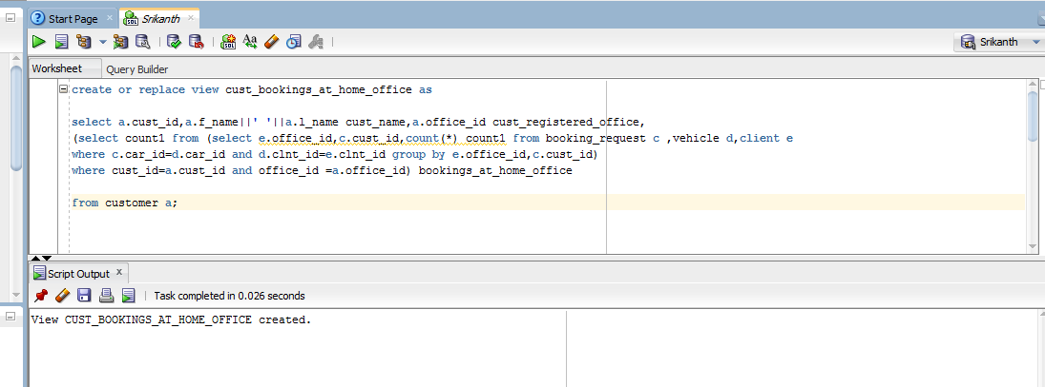

**Output:**

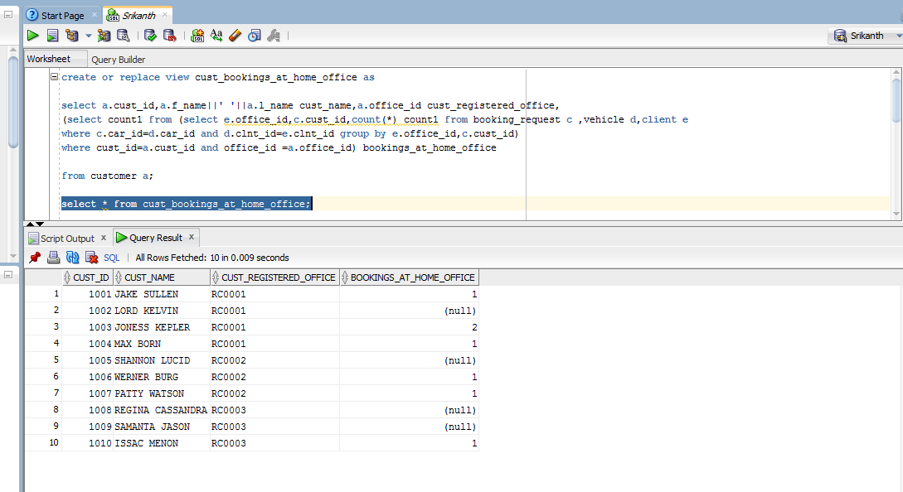

**12 k)**

creating a view to list top 3 frequent visiting customers at any office.

**Query:**

create or replace view frequent_customers as

select a.office_id,a.cust_id,a.f_name||' '||a.l_name cust_name,

(select count1 from (select cust_id,count(*) count1 from booking_request group by cust_id) where cust_id=a.cust_id) no_of_visits from

customer a where rownum<=3 order by no_of_visits desc;

**Output:**

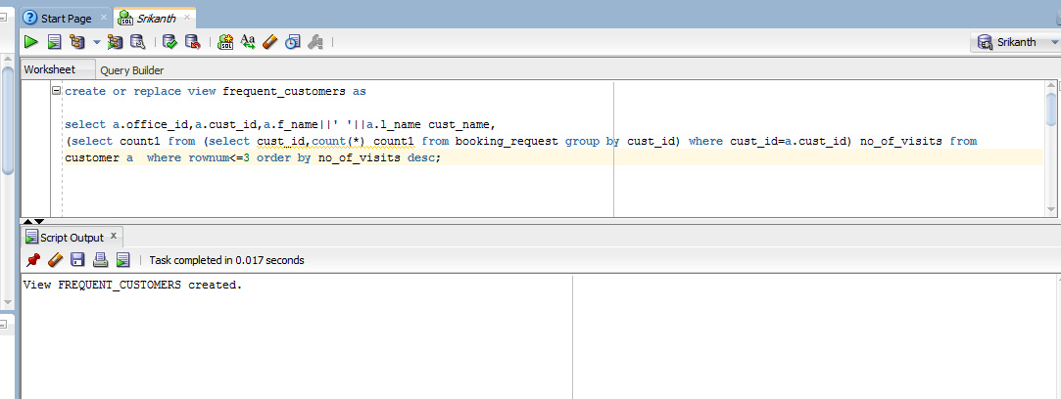

**Output:**

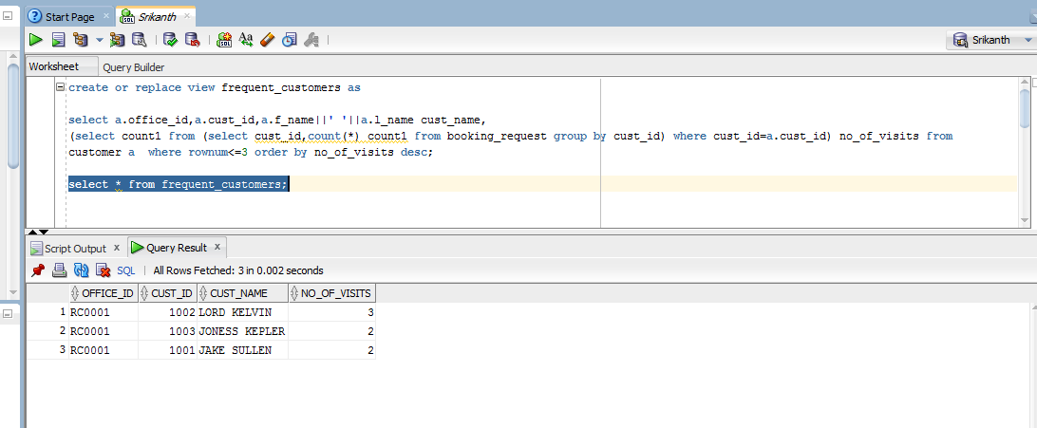

**13 a)**  Index on Customer First & Last name

**Query:**

create index customer_name on customer(f_name,m_name,l_name);

**Output:**

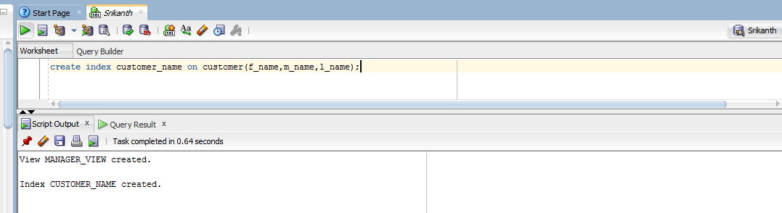

**13 b)** Creating Index on Birthdate of Customer

**Query:**

create index cust_bdate on customer(birth_date);

**Output:**

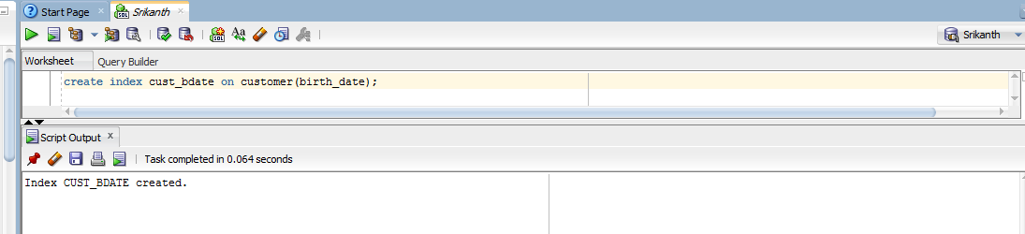

**14 a)** Creating sequence ‘ ID_generator’

**Query:**

create sequence ID_generator increment by 2 start with 1000 cache 40;

**Output:**

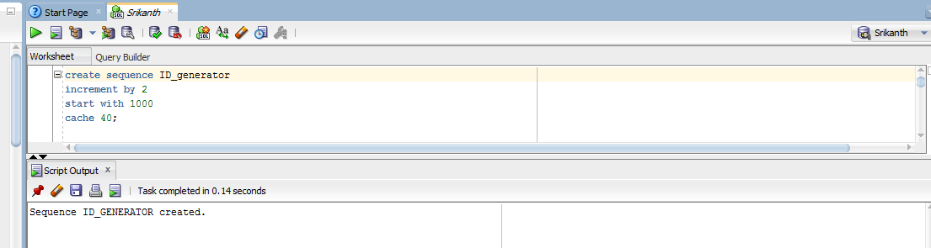

**14 b)** Creating sequence for the Transaction ID.

**Query:**

create sequence tran_id_sequence increment by 1 start with 1001000 nocycle;

**Output:**

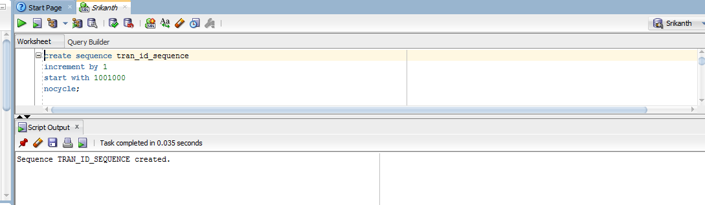

**14 c)** creating sequence called track number,start with zero and increment by one.

**Query:**

create sequence track_number increment by 1 start with 0

minvalue 0

maxvalue 99999;

**Output:**

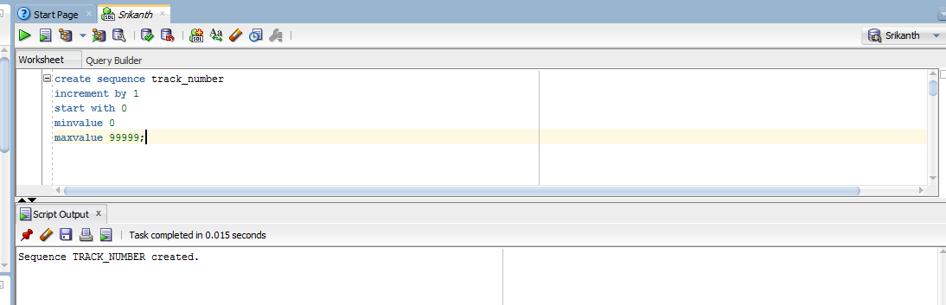

**14 d)**

**Query:**

create table inquiries(inq_no number,inquiry_date date,

type_of_req varchar2(10),name_of_person varchar2(15),email varchar2(25));

**Output:**

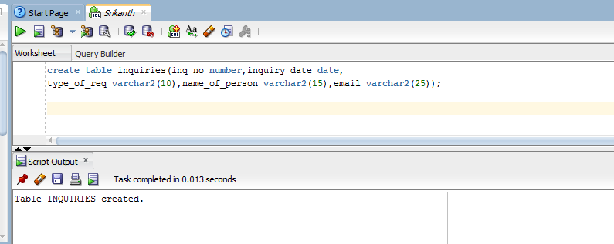

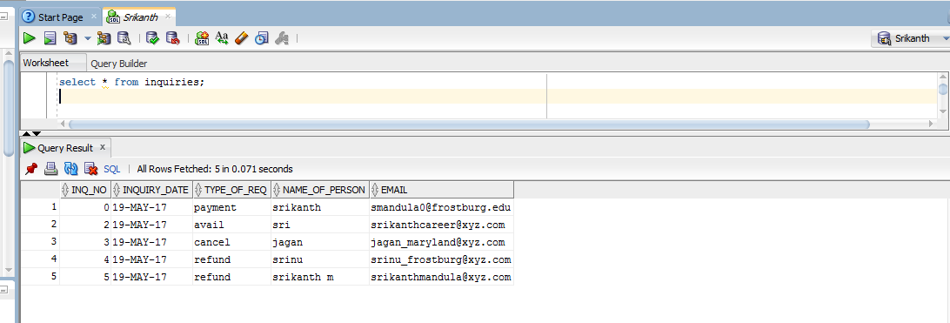

**SubPrograms & Packages with exception handling :**

**15 a)** Creating package EmpInser_pkg

**Program :**

create or replace package EmpInsert_pkg as

procedure insert_new_emp(v_emp_id emp.emp_id%type,v_office_id emp.office_id%type,v_f_name emp.f_name%type,v_m_name emp.m_name%type,

v_l_name emp.l_name%type,v_gender emp.gender%type,v_flat_no emp.flat_no%type,v_street_name emp.street_name%type,

v_city emp.city%type,v_state emp.state%type,v_zipcode emp.zipcode%type,v_ssn emp.ssn%type,v_salary emp.salary%type,

v_tax_deduction emp.tax_deduction%type,v_dob emp.dob%type,v_marital_status emp.marital_status%type,v_spouse_name emp.spouse_name%type,

v_hiring_date emp.hiring_date%type,v_divorce_status emp.divorce_status%type,v_previous_name emp.previous_name%type,

v_no_of_years_at_office emp.no_of_years_at_office%type,v_no_of_years_at_company emp.no_of_years_at_company%type,

v_last_degree emp.last_degree%type,v_no_of_dependents emp.no_of_dependents%type,v_home_ph_no emp.home_ph_no%type,

v_cell_ph_no emp.cell_ph_no%type,v_emp_mgr_id emp.emp_id%type,v_mgr_title manager.mgr_title%type);

procedure emp_marital_status_update(v_emp emp.emp_id%type,v_marital_status emp.marital_status%type);

procedure emp_last_degree_update(v_emp emp.emp_id%type,v_last_degree emp.last_degree%type);

procedure emp_certificate_update(v_emp emp_certificates.emp_id%type,v_certificate emp_certificates.certificate%type);

procedure emp_manager_update(v_emp emp.emp_id%type,v_mgr_id emp.mgr_id%type);

end EmpInsert_pkg;

create or replace package body EmpInsert_pkg as

procedure insert_new_emp(v_emp_id emp.emp_id%type,v_office_id emp.office_id%type,v_f_name emp.f_name%type,v_m_name emp.m_name%type,

v_l_name emp.l_name%type,v_gender emp.gender%type,v_flat_no emp.flat_no%type,v_street_name emp.street_name%type,

v_city emp.city%type,v_state emp.state%type,v_zipcode emp.zipcode%type,v_ssn emp.ssn%type,v_salary emp.salary%type,

v_tax_deduction emp.tax_deduction%type,v_dob emp.dob%type,v_marital_status emp.marital_status%type,v_spouse_name emp.spouse_name%type,

v_hiring_date emp.hiring_date%type,v_divorce_status emp.divorce_status%type,v_previous_name emp.previous_name%type,

v_no_of_years_at_office emp.no_of_years_at_office%type,v_no_of_years_at_company emp.no_of_years_at_company%type,

v_last_degree emp.last_degree%type,v_no_of_dependents emp.no_of_dependents%type,v_home_ph_no emp.home_ph_no%type,

v_cell_ph_no emp.cell_ph_no%type,v_emp_mgr_id emp.emp_id%type,v_mgr_title manager.mgr_title%type) as

begin

insert into MANAGER values(v_emp_mgr_id,v_emp_id,v_mgr_title);

insert into emp values( v_emp_id,v_office_id,v_f_name,v_m_name,v_l_name,v_gender,v_flat_no,v_street_name,v_city,v_state,

v_zipcode,v_ssn,v_salary,v_tax_deduction,v_dob,v_marital_status,v_spouse_name,v_hiring_date,v_divorce_status,v_previous_name,

v_no_of_years_at_office,v_no_of_years_at_company,v_last_degree,v_no_of_dependents,v_home_ph_no,v_cell_ph_no,v_emp_mgr_id);

dbms_output.put_line('new employee data inserted successfully into emp table and Manger table is also updated');

exception

when others then

dbms_output.put_line('Error occured in updating the employee or manager table');

end;

procedure emp_marital_status_update(v_emp emp.emp_id%type,v_marital_status emp.marital_status%type) as

begin

update emp set marital_status = v_marital_status where emp_id=v_emp;

dbms_output.put_line('Employee marital status updated successfully');

exception

when no_data_found then

dbms_output.put_line('There is no employee available with the given data');

when too_many_rows then

dbms_output.put_line('there are multiple employees available with the given data');

when others then

dbms_output.put_line('there is some error occured .Please check');

end;

procedure emp_last_degree_update(v_emp emp.emp_id%type,v_last_degree emp.last_degree%type) as

begin

update emp set last_degree = v_last_degree where emp_id=v_emp;

dbms_output.put_line('Employee last degree updated successfully');

exception

when no_data_found then

dbms_output.put_line('There is no employee available with the given data');

when too_many_rows then

dbms_output.put_line('there are multiple employees available with the given data');

when others then

dbms_output.put_line('there is some error occured .Please check');

end;

procedure emp_certificate_update(v_emp emp_certificates.emp_id%type,v_certificate emp_certificates.certificate%type) as

begin

update emp_certificates set certificate = v_certificate where emp_id=v_emp;

dbms_output.put_line('Employee certificate status updated successfully');

exception

when no_data_found then

dbms_output.put_line('There is no employee available with the given data');

when too_many_rows then

dbms_output.put_line('there are multiple employees available with the given data');

when others then

dbms_output.put_line('there is some error occured .Please check');

end;

procedure emp_manager_update(v_emp emp.emp_id%type,v_mgr_id emp.mgr_id%type) as

begin

update emp set mgr_id = v_mgr_id where emp_id=v_emp;

update manager set manager_id = v_mgr_id where rep_emp_id=v_emp;

dbms_output.put_line('Employee manager updated successfully');

exception

when no_data_found then

dbms_output.put_line('There is no employee available with the given data');

when too_many_rows then

dbms_output.put_line('there are multiple employees available with the given data');

when others then

dbms_output.put_line('there is some error occured .Please check');

end;

end EmpInsert_pkg;

**Output:**

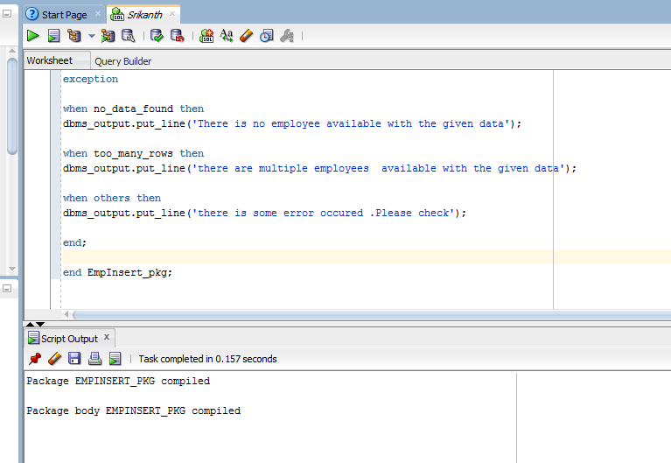

**15 b) Creating *Insert_pkg***

**Program :**

create or replace package Insert_pkg as

procedure insert_new_customer(v_cust_id customer.cust_id%type,v_office_id customer.office_id%type,v_f_name customer.f_name%type,v_m_name customer.m_name%type,

v_l_name customer.l_name%type,v_birth_date customer.birth_date%type,v_cell_phone customer.cell_phone%type,

v_flatno customer.flatno%type,v_street_name customer.street_name%type,v_city customer.city%type,v_state customer.state%type,

v_zipcode customer.zipcode%type,v_email_id customer.email_id%type,v_dl_num customer.dl_num%type,

v_credit_card_no customer.credit_card_no%type,v_card_exp_date customer.card_exp_date%type,v_dl_state dl.dl_state%type,

v_dl_issued_date dl.dl_issued_date%type,v_dl_valid_upto dl.dl_valid_upto%type,v_remarks dl.remarks%type);

procedure insert_new_client(v_clnt_id client.clnt_id%type,v_office_id client.office_id%type,v_ssn client.ssn%type,

v_f_name client.f_name%type,v_m_name client.m_name%type,v_l_name client.l_name%type,v_dob client.dob%type,

v_flat_no client.flat_no%type,v_street_name client.street_name%type,v_city client.city%type,v_state client.state%type,

v_zipcode client.zipcode%type,v_home_ph client.home_ph%type,v_cell_ph client.cell_ph%type,

v_email client.email%type,v_cc_no client.cc_no%type,v_card_exp_date client.card_exp_date%type,v_emp_id emp.emp_id%type,v_is_employee checks.is_employee%type,

v_clnt_emp_id checks.clnt_emp_id%type,v_credit_score checks.credit_score%type,v_scored_date checks.scored_date%type,

v_remarks checks.remarks%type);

procedure customer_info_update(v_cust_id customer.cust_id%type,v_cell_phone customer.cell_phone%type);

procedure client_info_update(v_clnt_id client.clnt_id%type,v_email client.email%type);

procedure insert_new_tran(v_tran_id transaction.tran_id%type,v_booking_id transaction.booking_id%type,

v_tran_date transaction.tran_date%type,v_amount transaction.amount%type,v_miles_run transaction.miles_run%type);

procedure insert_accident_record(v_booking_id accident.booking_id%type,v_accident_date accident.accident_date%type,

v_accident_time accident.accident_time%type,v_place accident.place%type,v_ext_of_damage accident.ext_of_damage%type,

v_cost_of_damage accident.cost_of_damage%type,v_police_report accident.police_report%type,v_summary_report accident.summary_report%type,

v_remarks accident.remarks%type);

end Insert_pkg;

create or replace package body Insert_pkg as

procedure insert_new_customer(v_cust_id customer.cust_id%type,v_office_id customer.office_id%type,v_f_name customer.f_name%type,v_m_name customer.m_name%type,

v_l_name customer.l_name%type,v_birth_date customer.birth_date%type,v_cell_phone customer.cell_phone%type,

v_flatno customer.flatno%type,v_street_name customer.street_name%type,v_city customer.city%type,v_state customer.state%type,

v_zipcode customer.zipcode%type,v_email_id customer.email_id%type,v_dl_num customer.dl_num%type,

v_credit_card_no customer.credit_card_no%type,v_card_exp_date customer.card_exp_date%type,v_dl_state dl.dl_state%type,

v_dl_issued_date dl.dl_issued_date%type,v_dl_valid_upto dl.dl_valid_upto%type,v_remarks dl.remarks%type) as

begin

insert into DL values(v_dl_num,v_dl_state,v_dl_issued_date,v_dl_valid_upto,v_remarks);

insert into customer values(v_cust_id,v_office_id,v_f_name,v_m_name,v_l_name,v_birth_date,v_cell_phone,

v_flatno,v_street_name,v_city,v_state,v_zipcode,v_email_id,v_dl_num,v_credit_card_no,v_card_exp_date);

dbms_output.put_line('new customer data inserted successfully into customer table and DL table is also updated');

exception

when others then

dbms_output.put_line('Error occured in updating customer table');

end;

procedure insert_new_client(v_clnt_id client.clnt_id%type,v_office_id client.office_id%type,v_ssn client.ssn%type,

v_f_name client.f_name%type,v_m_name client.m_name%type,v_l_name client.l_name%type,v_dob client.dob%type,

v_flat_no client.flat_no%type,v_street_name client.street_name%type,v_city client.city%type,v_state client.state%type,

v_zipcode client.zipcode%type,v_home_ph client.home_ph%type,v_cell_ph client.cell_ph%type,

v_email client.email%type,v_cc_no client.cc_no%type,v_card_exp_date client.card_exp_date%type,v_emp_id emp.emp_id%type,v_is_employee checks.is_employee%type,

v_clnt_emp_id checks.clnt_emp_id%type,v_credit_score checks.credit_score%type,v_scored_date checks.scored_date%type,

v_remarks checks.remarks%type) as

begin

insert into client values(v_clnt_id,v_office_id,v_ssn,v_f_name,v_m_name,v_l_name,v_dob,v_flat_no,v_street_name,v_city,

v_state,v_zipcode,v_home_ph,v_cell_ph,v_email,v_cc_no,v_card_exp_date);

insert into checks values(v_emp_id,v_clnt_id,v_is_employee,v_clnt_emp_id,v_credit_score,v_scored_date,v_remarks);

exception

when others then

dbms_output.put_line('there is some error occured .Please check');

end;

procedure customer_info_update(v_cust_id customer.cust_id%type,v_cell_phone customer.cell_phone%type) as

begin

update customer set cell_phone = v_cell_phone where cust_id=v_cust_id;

dbms_output.put_line('Customer cell phone updated successfully');

exception

when no_data_found then

dbms_output.put_line('There is no customer available with the given data');

when too_many_rows then

dbms_output.put_line('there are multiple customers available with the given data');

when others then

dbms_output.put_line('there is some error occured .Please check');

end;

procedure client_info_update(v_clnt_id client.clnt_id%type,v_email client.email%type) as

begin

update client set email = v_email where clnt_id=v_clnt_id;

dbms_output.put_line('Client email updated successfully');

exception

when no_data_found then

dbms_output.put_line('There is no client available with the given data');

when too_many_rows then

dbms_output.put_line('there are multiple clients available with the given data');

when others then

dbms_output.put_line('there is some error occured .Please check');

end;

procedure insert_new_tran(v_tran_id transaction.tran_id%type,v_booking_id transaction.booking_id%type,

v_tran_date transaction.tran_date%type,v_amount transaction.amount%type,v_miles_run transaction.miles_run%type) as

begin

insert into transaction values(v_tran_id,v_booking_id,v_tran_date,v_amount,v_miles_run);

dbms_output.put_line('transaction record added successfully');

exception

when others then

dbms_output.put_line('there is some error occured .Please check');

end;

procedure insert_accident_record(v_booking_id accident.booking_id%type,v_accident_date accident.accident_date%type,

v_accident_time accident.accident_time%type,v_place accident.place%type,v_ext_of_damage accident.ext_of_damage%type,

v_cost_of_damage accident.cost_of_damage%type,v_police_report accident.police_report%type,v_summary_report accident.summary_report%type,

v_remarks accident.remarks%type) as

begin

insert into accident values(v_booking_id,v_accident_date,v_accident_time,v_place,v_ext_of_damage,v_cost_of_damage,

v_police_report,v_summary_report,v_remarks);

dbms_output.put_line('accident record added successfully');

exception

when others then

dbms_output.put_line('there is some error occured .Please check');

end;

end Insert_pkg;

**Output:**

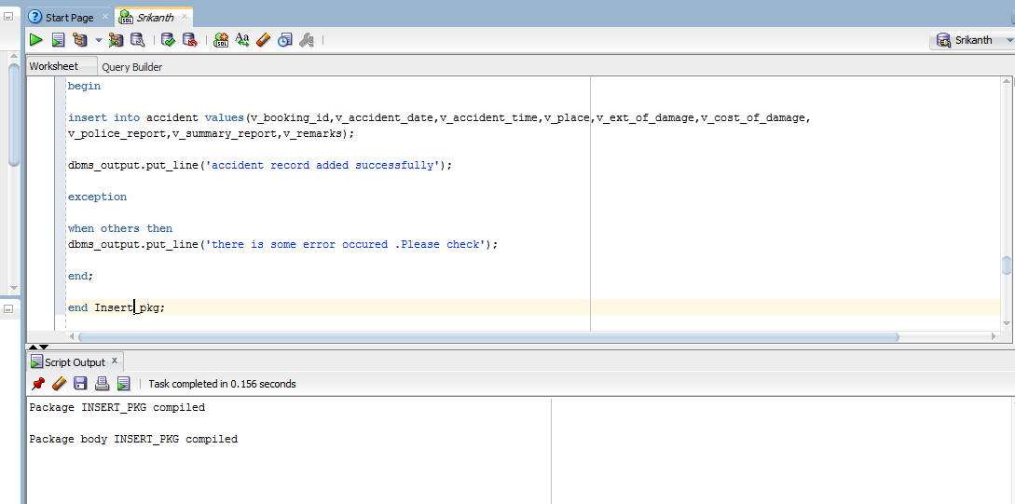

**15 c) Creating *Vehicle_pkg***

**Program :**

create or replace package Vehicle_pkg as

function Car_info(v_car_id vehicle.car_id%type) return varchar2;

procedure CarOwner(SSN1 client.ssn%type);

procedure CarRented(v_car_id vehicle.car_id%type);

procedure CarRented(v_cust_id customer.cust_id%type);

end Vehicle_pkg;

create or replace package body Vehicle_pkg as

function Car_info(v_car_id vehicle.car_id%type) return varchar2 as

v_plate_no vehicle.car_info%type;

v_make vehicle.make%type;

v_year vehicle.year%type;

v_curr_mileage vehicle.curr_mileage%type;

v_class vehicle.class%type;

v_color vehicle.color%type;

v_feature vehicle.ffeatures%type;

v_car_description vehicle.car_description%type;

result varchar2(500);

begin

select car_info,make,year,curr_mileage,class,color,ffeatures,car_description into v_plate_no,v_make,v_year,v_curr_mileage,v_class,v_color,v_feature,v_car_description from vehicle where car_id=v_car_id;

result := 'plate no :'||v_plate_no||' ,make : '||v_make||' ,year : '||v_year||' ,current mileage : '||v_curr_mileage||' ,class : '||v_class||' ,color : '||v_color||' ,features : '||v_feature||' ,car description : '||v_car_description;

return result;

exception

when no_data_found then

dbms_output.put_line('There is no vehicle available with the given data');

when too_many_rows then

dbms_output.put_line('there are multiple vehicles available with the given data');

when others then

dbms_output.put_line('Error occured in updating customer table');

end;

procedure CarOwner(SSN1 client.ssn%type) as

v_name varchar2(100);

v_car_id vehicle.car_id%type;

v_car_info vehicle.car_info%type;

v_no_of_rents number default 0;

v_no_of_accidents number default 0;

v_booking_id booking_request.booking_id%type;

v_temp_car_id vehicle.car_id%type;

cursor c1 is

select car_id,car_info from vehicle where clnt_id=(select clnt_id from client where ssn=ssn1);

cursor c2 is

select booking_id from accident;

begin

select f_name||' '||m_name||' '||l_name into v_name from client where ssn=ssn1;

dbms_output.put_line('Car Owner SSN is : '||SSN1);

dbms_output.put_line('Car Owner name is : '||v_name);

dbms_output.put_line('details of car/cars owned by this owner :');

open c1;

loop

fetch c1 into v_car_id,v_car_info;

exit when c1%notfound;

dbms_output.put_line('car_id : '||v_car_id||' , plate No : '||v_car_info);

select count(*) into v_no_of_rents from booking_request where car_id=v_car_id;

dbms_output.put_line('Number of times this car rented is : '||v_no_of_rents);

open c2;

loop

fetch c2 into v_booking_id;

exit when c2%notfound;

select car_id into v_temp_car_id from booking_request where booking_id=v_booking_id;

if(v_temp_car_id=v_car_id) then

v_no_of_accidents :=v_no_of_accidents+1;

end if;

end loop;

dbms_output.put_line('Number of times this car involved in accidents is : '||v_no_of_accidents);

close c2;

end loop;

close c1;

exception

when others then

dbms_output.put_line('there is some error occured .Please check');

end;

procedure CarRented(v_car_id vehicle.car_id%type) as

v_cust_id booking_request.cust_id%type;

v_customer_name varchar2(100);

cursor cusor_cust_id is

select distinct cust_id from booking_request where car_id=v_car_id;

begin

dbms_output.put_line('Customers who rented the car : '||v_car_id||' are : ');

open cusor_cust_id;

loop

fetch cusor_cust_id into v_cust_id;

exit when cusor_cust_id%notfound;

select f_name||' '||m_name||' '||l_name into v_customer_name from customer where cust_id=v_cust_id;

dbms_output.put_line('Name : '||v_customer_name);

end loop;

exception

when no_data_found then

dbms_output.put_line('There is no car available with the given data');

when too_many_rows then

dbms_output.put_line('there are multiple cars available with the given data');

when others then

dbms_output.put_line('there is some error occured .Please check');

end;

procedure CarRented(v_cust_id customer.cust_id%type) as

v_car_id vehicle.car_id%type;

v_req_date booking_request.req_date%type;

prev_rented_date date;

last_rented_car_id vehicle.car_id%type;

counter number default 0;

cursor cars_rented is

select car_id,req_date from booking_request where cust_id=v_cust_id;

begin

open cars_rented;

loop

exit when cars_rented%notfound;

fetch cars_rented into v_car_id,v_req_date;

if (counter=0) then

prev_rented_date := v_req_date;

last_rented_car_id := v_car_id;

counter := counter+1;

elsif prev_rented_date<v_req_date then

last_rented_car_id :=v_car_id;

end if;

end loop;

close cars_rented;

dbms_output.put_line('The last car rented by customer '||v_cust_id|| 'is : '||last_rented_car_id);

exception

when no_data_found then

dbms_output.put_line('There is no customer available with the given data');

when too_many_rows then

dbms_output.put_line('there are multiple customers available with the given data');

when others then

dbms_output.put_line('there is some error occured .Please check');

end;

end Vehicle_pkg;

**Output:**

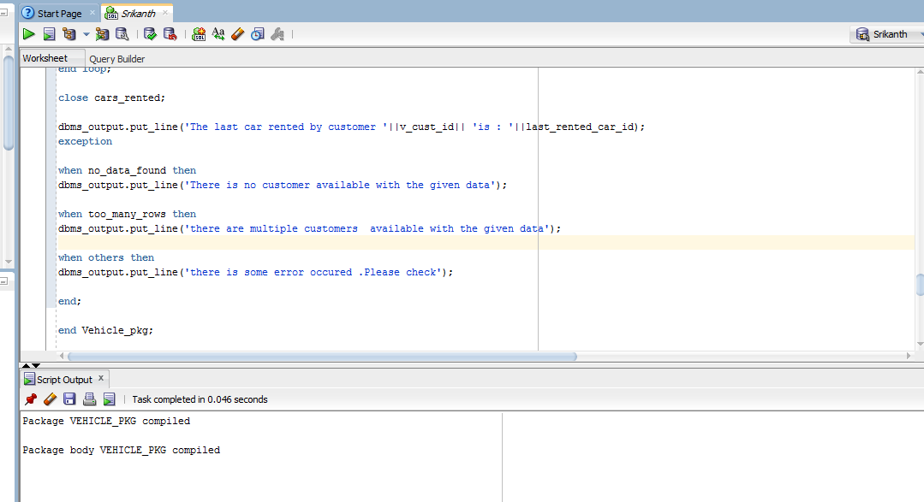

**15 d) Creating *Accident_pkg***

**Program :**

create or replace package Accident_pkg as

function CarAccident(v_car_id vehicle.car_id%type) return varchar2;

function CustomerAccident(v_cust_id customer.cust_id%type) return boolean;

end Accident_pkg;

create or replace package body Accident_pkg as

function CarAccident(v_car_id vehicle.car_id%type) return varchar2 as

v_cust_name varchar2(50);

v_cell_phone customer.cell_phone%type;

v_cust_address varchar2(100);

v_accident_date accident.accident_date%type;

v_accident_time accident.accident_time%type;

v_accident_place accident.place%type;

v_ext_of_damage accident.ext_of_damage%type;

v_cost_of_damage accident.cost_of_damage%type;

result varchar2(500);

counter number default 0;

v_last_accident_date accident.accident_date%type;

v_temp_accident_date accident.accident_date%type;

v_booking_id accident.booking_id%type;

v_cust_id booking_request.cust_id%type;

v_temp_car_id vehicle.car_id%type;

v_temp_car_id2 vehicle.car_id%type;

v_booking_id_temp accident.booking_id%type;

req_accident_id booking_request.booking_id%type;

cursor accident_ids is

select booking_id from accident;

cursor accident_ids_temp is

select booking_id from accident;

begin

open accident_ids;

loop

fetch accident_ids into v_booking_id;

exit when accident_ids%notfound;

select car_id into v_temp_car_id from booking_request where booking_id=v_booking_id;

select accident_date into v_last_accident_date from accident where booking_id=v_booking_id;

if (v_temp_car_id=v_car_id) then

counter := counter+1;

open accident_ids_temp;

loop

fetch accident_ids_temp into v_booking_id_temp;

exit when accident_ids_temp%notfound;

select car_id into v_temp_car_id2 from booking_request where booking_id=v_booking_id_temp;

select accident_date into v_temp_accident_date from accident where booking_id=v_booking_id_temp;

if (v_temp_car_id2=v_car_id and v_last_accident_date<=v_temp_accident_date) then

select booking_id into req_accident_id from accident where booking_id=v_booking_id_temp;

end if;

end loop;

close accident_ids_temp;

select cust_id into v_cust_id from booking_request where booking_id=req_accident_id;

select accident_date,accident_time,place,ext_of_damage,cost_of_damage into

v_accident_date,v_accident_time,v_accident_place,v_ext_of_damage,v_cost_of_damage from accident where booking_id=req_accident_id;

select f_name||' '||m_name||' '||l_name,cell_phone,flatno||','||street_name||', '||city||', '||state||' ,'||zipcode

into v_cust_name,v_cell_phone,v_cust_address from customer where cust_id=v_cust_id;

result := 'Customer Name : '||v_cust_name||' , cell phone is : '||v_cell_phone||' Address is : '||v_cust_address||

' ,accident date is : '||v_accident_date||' , accident time is : '||v_accident_time||' , accident place is : '||v_accident_place

||' , extent of damage is : '||v_ext_of_damage||' , cost of damage is : '||v_cost_of_damage;

end if;

end loop;

close accident_ids;

if(counter=0) then

result := 'There is no accident involved with this car';

end if;

return result;

exception

when no_data_found then

dbms_output.put_line('There is no vehicle available with the given data');

when too_many_rows then

dbms_output.put_line('there are multiple vehicles available with the given data');

when others then

dbms_output.put_line('Error occured in updating customer table');

end;

function CustomerAccident(v_cust_id customer.cust_id%type) return boolean as

v_booking_id booking_request.booking_id%type;

req_cust_id customer.cust_id%type;

counter number default 0;

cursor accident_ids is

select booking_id from accident;

begin

open accident_ids;

loop

fetch accident_ids into v_booking_id;

exit when accident_ids%notfound;

select cust_id into req_cust_id from booking_request where booking_id=v_booking_id;

if(v_cust_id=req_cust_id) then

counter := counter+1;

end if;

end loop;

close accident_ids;

if(counter >0) then

return true;

else

return false;

end if;

exception

when no_data_found then

dbms_output.put_line('There is no vehicle available with the given data');

when too_many_rows then

dbms_output.put_line('there are multiple vehicles available with the given data');

when others then

dbms_output.put_line('Error occured in updating customer table');

end;

end Accident_pkg;

**Output:**

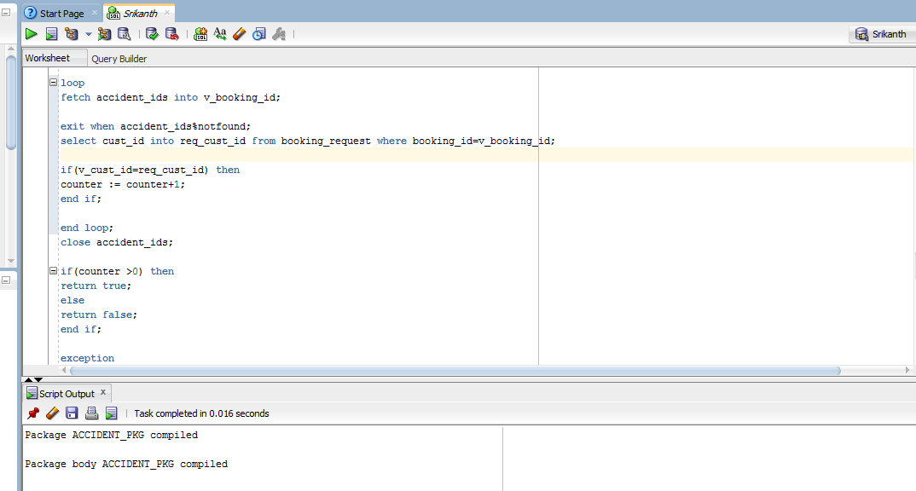

**15 e) Creating subprogram *BirthdaySub***

**Program :**

create table BIRTHDAYFILE(f_name varchar2(50),l_name varchar2(50),email_id varchar2(50),address varchar2(100));

create or replace procedure BirthdaySub(given_date date) as

v_cust_id customer.cust_id%type;

v_cust_bday customer.birth_date%type;

v_compare_date date;

dif number default 0;

v_f_name customer.f_name%type;

v_l_name customer.l_name%type;

v_email_id customer.email_id%type;

v_address varchar2(100);

temp_string varchar2(50);

no_of_rows number;

cursor cust_bday is

select cust_id,birth_date from customer;

begin

select count(*) into no_of_rows from birthdayfile;

if(no_of_rows>0) then

delete from birthdayfile;

end if;

open cust_bday;

loop

fetch cust_bday into v_cust_id,v_cust_bday;

exit when cust_bday%notfound;

temp_string := to_char(v_cust_bday,'dd')||'/'||to_char(v_cust_bday,'mm')||'/'||to_char(given_date,'yyyy');

v_compare_date := to_date(temp_string,'dd-mm-yyyy');

dif := v_compare_date - given_date;

if( abs(dif) <= 15) then

select f_name,l_name,email_id,flatno||' ,'||street_name||' ,'||city||' ,'||state||' ,'||zipcode into

v_f_name,v_l_name,v_email_id,v_address from customer where cust_id=v_cust_id;

dbms_output.put_line('First Name is : '||v_f_name||' ,last name is : '||v_l_name||' ,email id is : '||v_email_id||' ,address is : '||v_address);

insert into birthdayfile values(v_f_name,v_l_name,v_email_id,v_address);

end if;

end loop;

close cust_bday;

exception

when others then

dbms_output.put_line('there is some error occured .Please check');

end;

**Output:**

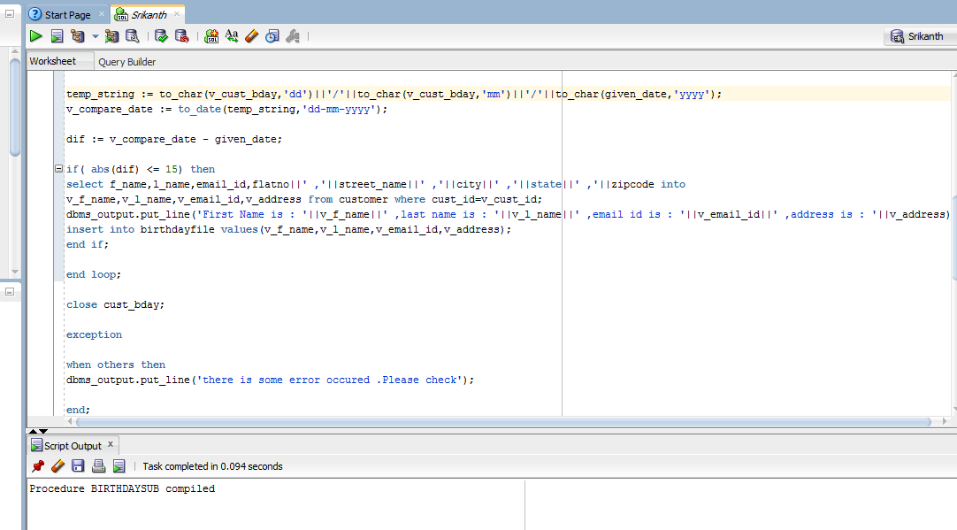

**15 f) Creating subprogram *Branch_manager_Info***

**Program :**

create or replace procedure branch_mgr_info is

v_office_id office.office_id%type;

v_office_name office.name%type;

v_mgr_id emp.emp_id%type;

v_mgr_hired_date emp.hiring_date%type;

cursor branch_cursor is

select office_id from office;

begin

open branch_cursor;

loop

fetch branch_cursor into v_office_id;

exit when branch_cursor%notfound;

select a.office_id,a.name,a.gm_id,b.hiring_date into v_office_id,v_office_name,v_mgr_id,v_mgr_hired_date from office a,emp b where a.office_id=v_office_id and a.gm_id=b.emp_id;

dbms_output.put_line('Office ID is : '||v_office_id);

dbms_output.put_line('Office name is : '||v_office_name);

dbms_output.put_line('Manager Id is : '||v_mgr_id);

dbms_output.put_line('Manager Hiring Date is : '||v_mgr_hired_date);

dbms_output.put_line('****************************');

end loop;

close branch_cursor;

exception

when others then

dbms_output.put_line('Error occured in procedure execution');

end;

**Output:**

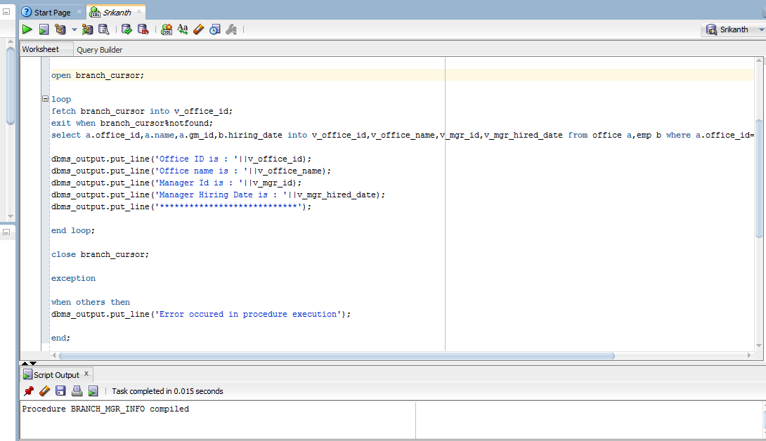

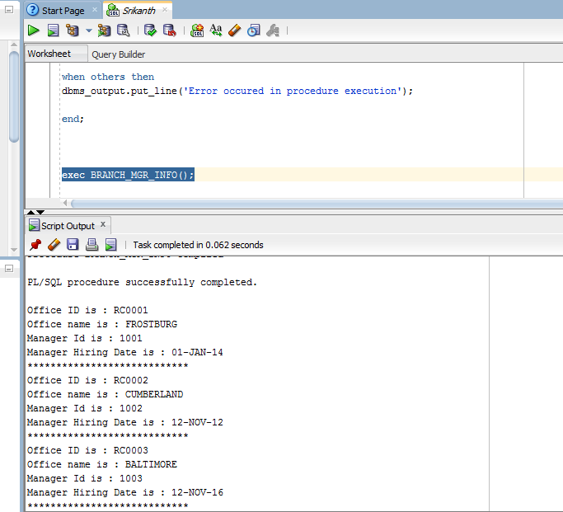

**16 g) Creating *Employee_History file* through *Triggers***

**Program :**

create or replace trigger emp_del_trigger after delete on emp for each row

declare

v_emp_rec emp%rowtype;

begin

v_emp_rec.emp_id := :OLD.emp_id;

v_emp_rec.office_id := :OLD.office_id;

v_emp_rec.f_name := :OLD.f_name;

v_emp_rec.m_name := :OLD.m_name;

v_emp_rec.l_name := :OLD.l_name;

v_emp_rec.gender := :OLD.gender;

v_emp_rec.flat_no := :OLD.flat_no;

v_emp_rec.street_name := :OLD.street_name;

v_emp_rec.city := :OLD.city;

v_emp_rec.state := :OLD.state;

v_emp_rec.zipcode := :OLD.zipcode;

v_emp_rec.ssn := :OLD.ssn;

v_emp_rec.salary := :OLD.salary;

v_emp_rec.tax_deduction := :OLD.tax_deduction;

v_emp_rec.dob := :OLD.dob;

v_emp_rec.marital_status := :OLD.marital_status;

v_emp_rec.spouse_name := :OLD.spouse_name;

v_emp_rec.hiring_date := :OLD.hiring_date;

v_emp_rec.divorce_status := :OLD.divorce_status;

v_emp_rec.previous_name := :OLD.previous_name;

v_emp_rec.no_of_years_at_office := :OLD.no_of_years_at_office;

v_emp_rec.no_of_years_at_company := :OLD.no_of_years_at_company;

v_emp_rec.last_degree := :OLD.last_degree;

v_emp_rec.no_of_dependents := :OLD.no_of_dependents;

v_emp_rec.home_ph_no := :OLD.home_ph_no;

v_emp_rec.mgr_id := :OLD.mgr_id;

insert into employee_history values(v_emp_rec.emp_id,v_emp_rec.office_id,v_emp_rec.f_name,v_emp_rec.m_name,v_emp_rec.l_name,v_emp_rec.gender,v_emp_rec.flat_no,

v_emp_rec.street_name,v_emp_rec.city,v_emp_rec.state,v_emp_rec.zipcode,v_emp_rec.ssn,v_emp_rec.salary,v_emp_rec.tax_deduction,

v_emp_rec.dob,v_emp_rec.marital_status,v_emp_rec.spouse_name,v_emp_rec.hiring_date,v_emp_rec.divorce_status,v_emp_rec.previous_name,

v_emp_rec.no_of_years_at_office,v_emp_rec.no_of_years_at_company,v_emp_rec.last_degree,v_emp_rec.no_of_dependents,v_emp_rec.home_ph_no,

v_emp_rec.cell_ph_no,v_emp_rec.mgr_id);

exception

when others then

dbms_output.put_line('error occured.please check');

end;

**Output:**

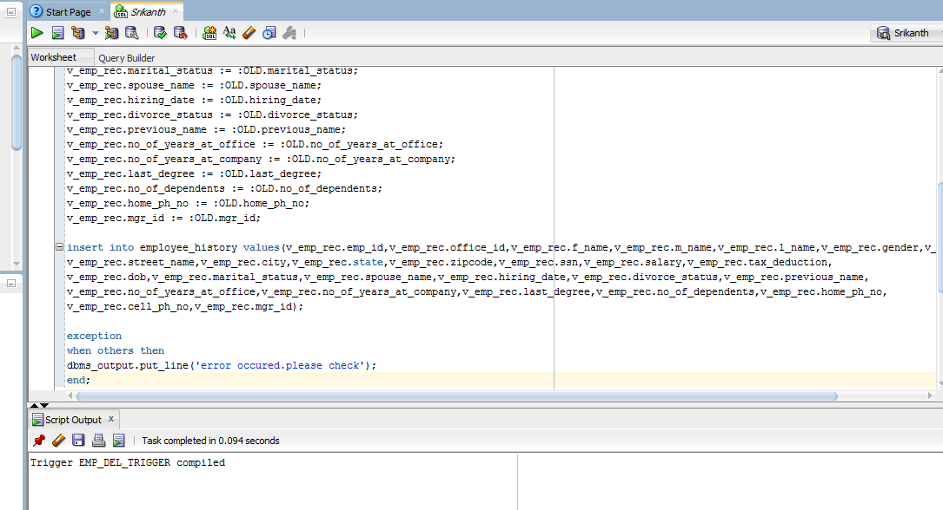

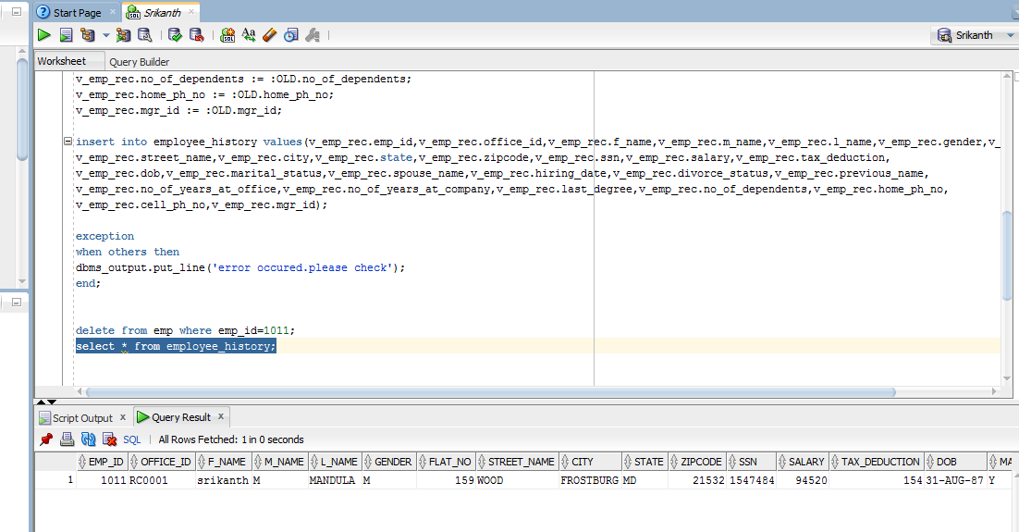

**16 h) Creating Customer_Log  *file* through *Triggers***

**Program :**

create table customer_log(username varchar2(30),tran_date date,nature_of_tran char);

create or replace trigger customer_mod_trigger after update or insert or delete on customer for each row

declare

v_change char(1);

begin

if inserting then

v_change := 'I';

elsif updating then

v_change := 'U';

else

v_change := 'D';

end if;

insert into customer_log values(user,sysdate,v_change);

exception

when others then

dbms_output.put_line('error occured.please check');

end;

**Output:**

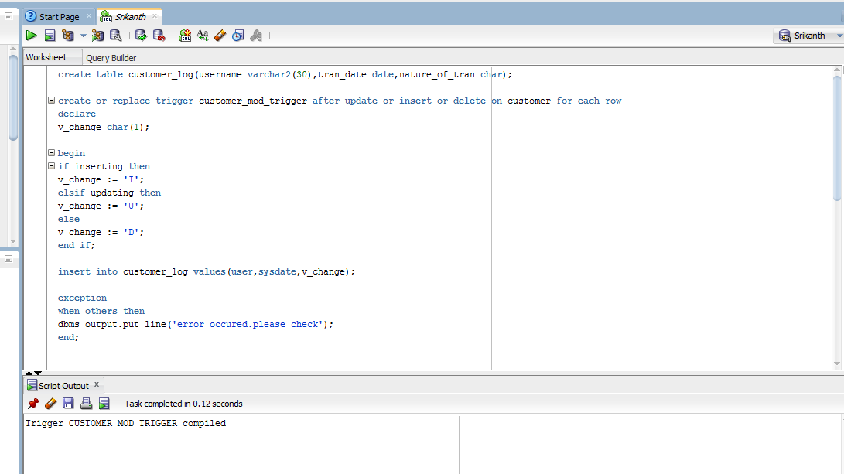

**16 i) Creating Accident_Log  *file* through *Triggers***

**Program :**

create table accident_log(cust_name varchar2(30),client_name varchar2(30),accident_date date);

create or replace trigger accident_trigger after insert on accident for each row

declare

v_booking_id booking_request.booking_id%type;

v_cust_name varchar2(50);

v_accident_date date;

v_client_name varchar2(30);

begin

v_booking_id := :NEW.booking_id;

v_accident_date := :NEW.accident_date;

select a.f_name||' '||a.l_name,b.f_name||' '||b.l_name into v_cust_name,v_client_name from customer a,client b,booking_request c,vehicle d

where c.booking_id= v_booking_id and c.cust_id=a.cust_id and c.car_id=d.car_id and d.clnt_id=b.clnt_id;

insert into accident_log values(v_cust_name,v_client_name,v_accident_date);

exception

when others then

dbms_output.put_line('error occured.please check');

end;

**Output:**

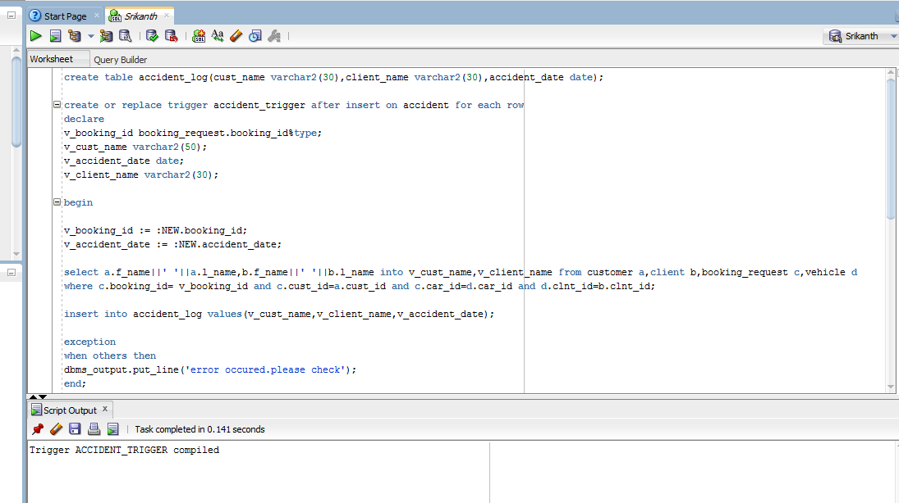

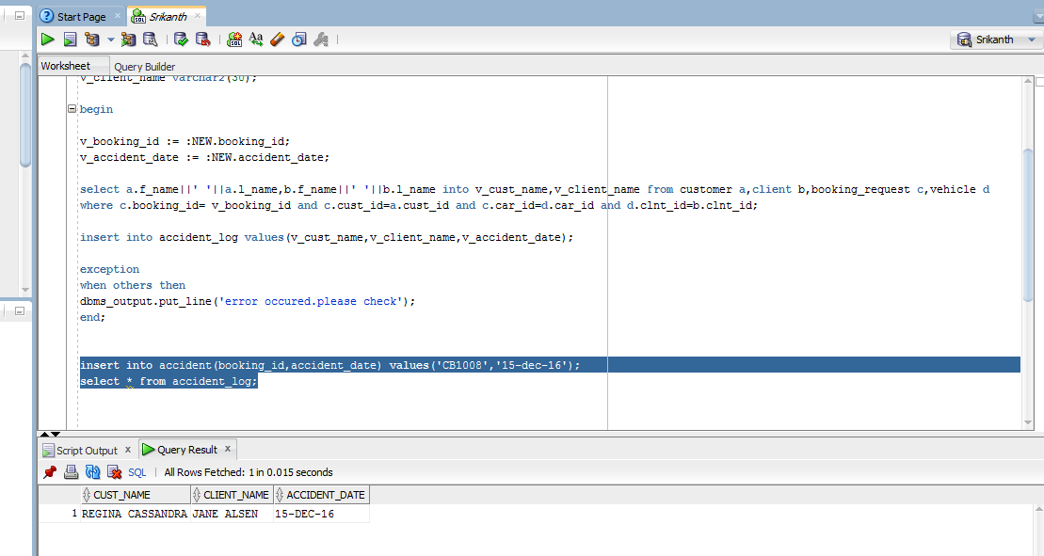

**17) Error_log file for errors in run time programs**

**Program :**

create or replace trigger accident_trigger before insert on accident for each row

declare

v_booking_id booking_request.booking_id%type;

v_cust_name varchar2(50);

v_accident_date date;

v_client_name varchar2(30);

accident_date_null Exception;

begin

v_booking_id := :NEW.booking_id;

v_accident_date := :NEW.accident_date;

if(:NEW.accident_date is null) then

raise accident_date_null;

end if;

select a.f_name||' '||a.l_name,b.f_name||' '||b.l_name into v_cust_name,v_client_name from customer a,client b,booking_request c,vehicle d

where c.booking_id= v_booking_id and c.cust_id=a.cust_id and c.car_id=d.car_id and d.clnt_id=b.clnt_id;

insert into accident_log values(v_cust_name,v_client_name,v_accident_date);

exception

when others then

begin

insert into error_log values('accident','accident_trigger',sysdate,'after each row');

end;

end;

create or replace trigger customer_mod_trigger after update or insert or delete on customer for each row

declare

v_change char(1);

begin

if inserting then

v_change := 'I';

elsif updating then

v_change := 'U';

else

v_change := 'D';

end if;

insert into customer_log values(user,sysdate,v_change);

exception

when others then

insert into error_log values('customer','customer_mod_trigger',sysdate,'after each row');

end;

end;

**Output:**

